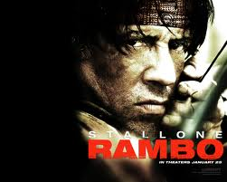
Get excited!!! This is our very first Action of the Past movie review and it’s for the return of one of the true action genre icons; Sylvester Stallone’s John Rambo. This movie has been called by several titles including Rambo4, John Rambo, and simply Rambo, but whatever you call it, it’s the fourth installment of the franchise. That being said, let’s get straight to the review. Our reviews are a bit different than those of other sites and definitely of your average professional critic. We don’t believe that all genre of movies should be reviewed and judged the same way. Not every movie is intended to be dramatic or to teach you a life lesson. And we feel that’s the case with action movies. So, we judge them on that basis. There are four categories we use to determine a movie’s overall score; fight scenes, story, stunts/effects, and the climax. Each of these categories has a possible thirty points out of a hundred with the exception of story which is allotted only ten. We believe story is important to some degree or it wouldn’t be in there at all. After all, you can’t get a perfect score without a good story. However, we understand something others don’t seem to. You don’t go to these movies so they can make you cry. You go so you can see someone get kicked through a wall, a crazy gunfight where nobody ever runs out of bullets, or explosions in every other scene. Don’t worry. We got you.

FIGHT SCENES:

There were definitely some good sequences in this movie. One in particular which stood out to me was kind of a quick draw scene between Rambo and some pirates. It was short, but very cool. However, there was very little hand to hand fighting going on in general and although the action was good, it wasn’t as frequent as one would generally expect from a Rambo movie.


STORY:

There was definitely a strong theme throughout the movie dealing with the real life strife in Burma. There really was not a lot to laugh at in this movie, but it doesn’t look like there was supposed to be either. So, mission accomplished there I guess. There was a fairly generic plot device in a group of well intentioned, but seemingly very ill prepared missionaries who set out into a literal war zone and at least one of them befriends Rambo on the way. Then, of course they get themselves caught, tortured, in some cases killed, etc. And Rambo goes in to save them. Unlike in previous movies, Rambo is not alone for much of the movie. There is a group of mercenaries accompanying him who really have no idea who they’re dealing with when it comes to Rambo…. At first anyway. So, this cuts down on some of the heavy lifting we would usually see done by Rambo alone. Another bit of story worth mentioning is the Rocky type flashbacks to Rambo’s past in this one. Although Colonel Troutman is not in the movie and presumably dead by now, we get to hear him repeatedly in Rambo’s thoughts and nightmares. It adds a little something. Still, the story seems a bit loose and I didn’t think they focused quite enough on Rambo himself, opting instead to spend more time to tell the story of the rebels fighting for survival in Burma. I understand the point in doing that, but there was also a bit of a pacing problem probably partly due to that. Some times the pace seemed really slow and other times everything seemed to be happening too fast.



This is a weak four, actually amounting to 7 out of the ten overall points for this category.

STUNTS/SPECIAL EFFECTS:

There were lots of gritty and gory effects in this one. They were pretty high quality in fact and I was surprised to learn that this film didn’t have big studio backing and presumably a smaller budget because of that. It doesn’t show at all. That being said, there are some times in the movie during action sequences when the “shaky camera” effect is used and personally, I hate that. It took away from not only the overall enjoyment of those sequences, but also made it harder to tell what exactly was going on at times.

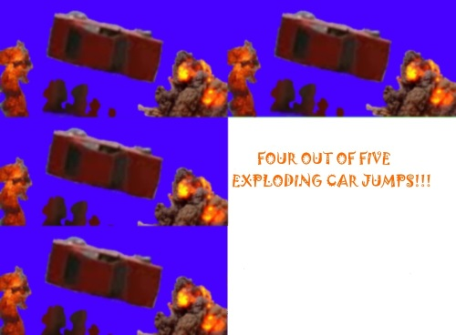

CLIMAX:

This brings us pretty close to the movie’s end. There’s LOTS of shooting. It’s cool, but felt short in some ways. And once again, it wasn’t as satisfying as when Rambo works alone. There was a lot of attention on the mercenaries and we see some ridiculous stuff going on too. Not only does one of the mercenaries who was wounded and ends up with only one leg actually manage to crawl over to someone and kill him, but one of the nonviolent missionaries manages to do essentially the same thing. There was maybe just a little too much going on for this to be as satisfying as it could have been…. But it was still good. And it was great just to see Rambo in action again. At the end, we even get to see him finally go home.
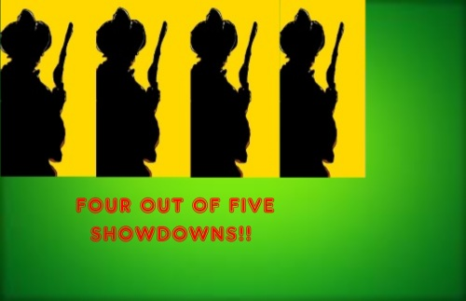

FINAL SCORE:

7.9/10

